Step 3: Configure the network settings on your Virtualbox (create NATNetwork in 10.0.0.0/24).
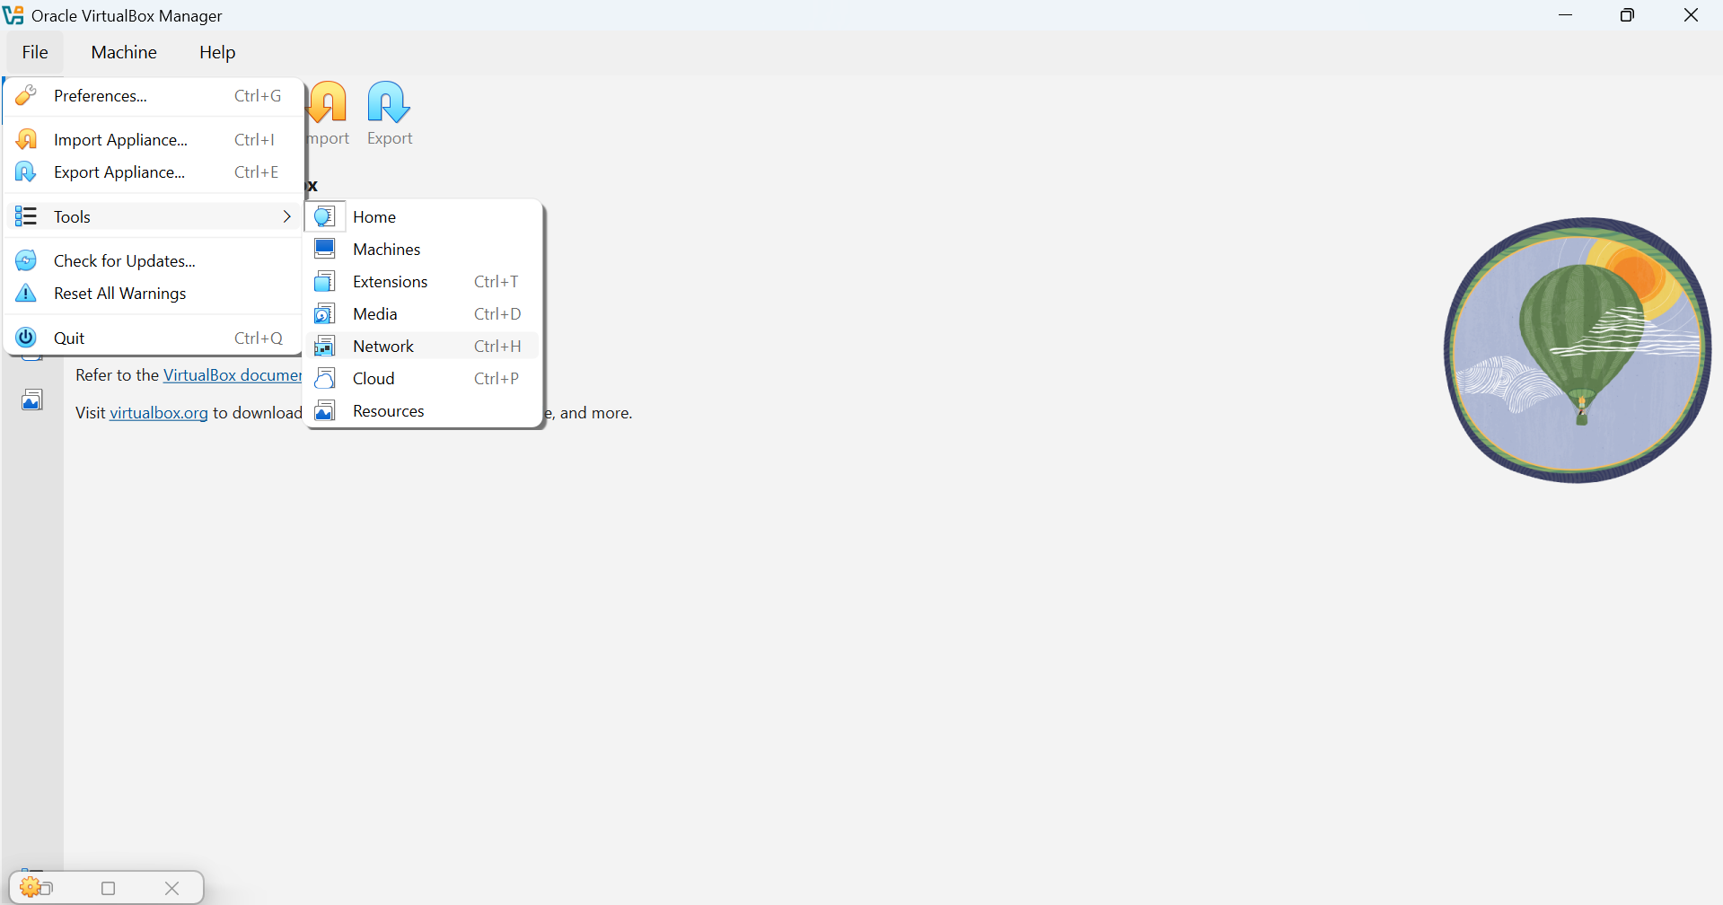
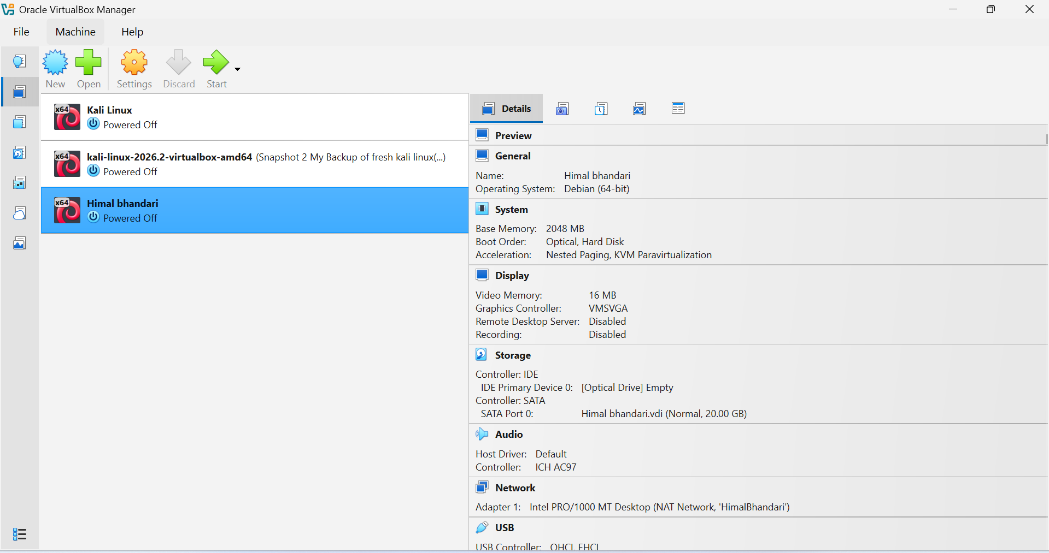
: File – Tools - Network - Create

